Dopamine Menu
Mental Health and Screen Time Activity for Post-Cyber Program
Learning Goals | - To identify non-screen related activities  - To encourage students to think about how social media and screens can impact their mental health  - To develop healthy, non-screen or social media related habits throughout the day
Materials | - Dopamine menu template  - Pencils
Set Up | - Print and hand out dopamine menu template for each student  - Prepare to have introductory conversation with students about impacts of social media on mental health
Length | - 30-35 Minutes

Introduction- 5 minutes
- Prior to this activity, begin a conversation with students about how much time they’re spending looking at screens in their daily life. Even if they don’t participate in social media or have phones, how much time are you spending on YouTube? Roblox or Fortnite?
- Ask students to either check the screen time on their phones (this can usually be found under the “settings” function of most phones) or to roughly estimate how many hours a day they spend looking at their phones, tablets, or laptops.
- Social media can be a great way to connect with people and keep up with what is going on in your friends’ lives; however, social media also comes with mental health risks.
- According to Yale School of Medicine, youth between the ages of 12 and 15 are twice as likely to develop negative mental health outcomes, like anxiety and depression, when they are using social media for 3 or more hours per day.
- Ask students:
  - Why do you think increased social media usage might lead to negative mental health?
  - How do you feel when you’ve been using social media or gaming for multiple hours?
- Consider the ways you might be comparing yourself to others online, the comments and messages people send, and how you feel after spending extended periods of time of social media.
- Following this discussion, ask students to brainstorm why doing more non-screen related activities might be beneficial for their mental health. Are there already some offline hobbies they enjoy doing or do regularly?

Activity – 15-20 minutes
Introduce Idea of Dopamine Menu: You may have heard before that social media can be addictive, and there’s science to prove that it is, in fact, very addictive! Social media is designed to activate the brain’s reward centre by releasing a hormone called dopamine.
- Dopamine is a “feel good” chemical that your brain naturally releases when you accomplish something or do something that makes you feel good. Social media is addictive because it triggers your brain to release dopamine when you are using it.
- However, if we think about all the negative side effects of social media use on our mental health and even our physical well-being, let’s find some alternative non-screen related dopamine triggers that make us feel good both physically and mentally.
- Today, you’ll be making a dopamine menu! Your dopamine menu will be divided into four key parts, much like the menu in a restaurant.
- You can follow this template:
- Appetizers
- Mains
- Sides
- Desserts
- Each part of your “menu” will relate to activities of varying lengths that you can do at any point throughout the day. You can use your menu to choose an activity when you need a pick-me-up throughout the day that doesn’t involve your phone or a screen.
- Appetizers (5–15-minute activities): “Appetizer” activities are very short, quick and easy actions and activities you can do throughout the day. These only need to take a few minutes and can include making a healthy snack, making your bed, or standing outside in the sun for a few minutes.
- Mains (30 minute – 2-hour activities): These activities may require a few hours to enjoy, but they are meant to re-energize you more than the appetizer activities. Some examples are going for a walk, learning a new skill like crocheting, or maybe meeting up with a friend in-person.
- Sides: These are activities that you can complete while performing other tasks, like listening to music while doing homework, or listening to a podcast episode while doing chores.
- Desserts: These are special activities that you can enjoy once in a while. Maybe it’s going to see a movie with friends, buying an outfit that makes you feel good, or maybe going to a hockey game. These are activities or things you can save for or look forward to.
Here is an example of a dopamine menu:
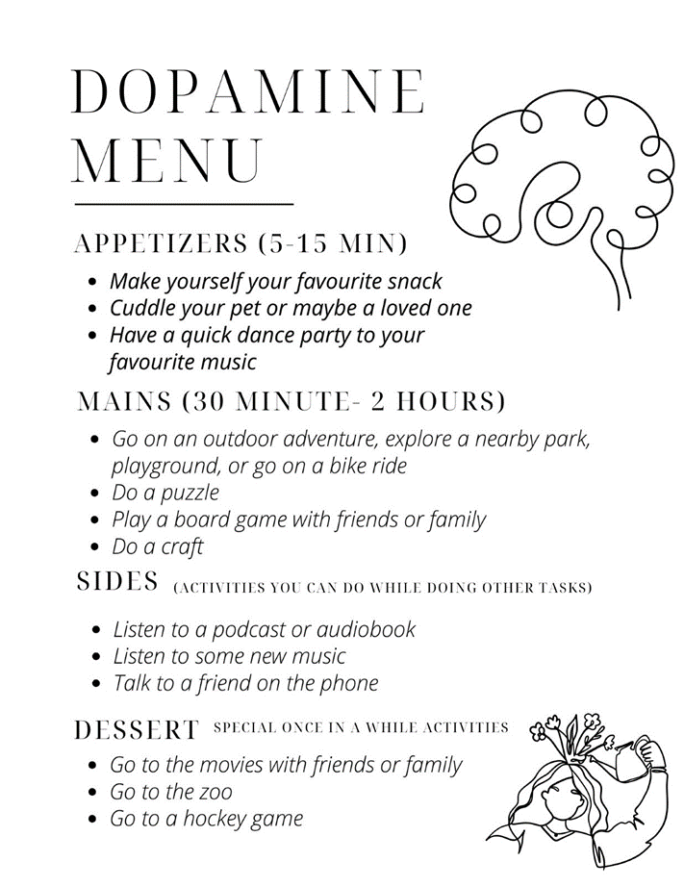

Conclusion – 5 minutes
- To conclude, ask students the following questions:
  - How are they going to use their dopamine menu?
  - When might be a good time to refer to it?
  - Is there a way they can use their dopamine menu to help them set and achieve some goals, maybe if they’re trying to learn a new skill or accomplish a larger goal?
  - What are some things they might add or change over time?

